Lab - Troubleshoot EIGRP for IPv4

# Topology

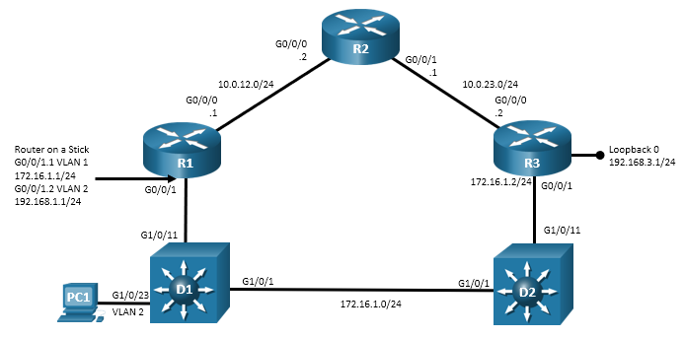

# Addressing Table

| Device | Interface | IP Address | Subnet Mask |
| --- | --- | --- | --- |
| R1 | G0/0/0 | 10.0.12.1 | 255.255.255.0 |
| R1 | G0/0/1.1 | 172.16.1.1 | 255.255.255.0 |
| R1 | G0/0/1.2 | 192.168.1.1 | 255.255.255.0 |
| R2 | G0/0/0 | 10.0.12.2 | 255.255.255.0 |
| R2 | G0/0/1 | 10.0.23.1 | 255.255.255.0 |
| R3 | G0/0/0 | 10.0.23.2 | 255.255.255.0 |
| R3 | G0/0/1 | 172.16.1.2 | 255.255.255.0 |
| R3 | Loopback 0 | 192.168.3.1 | 255.255.255.0 |
| PC1 | NIC | DHCP | |

# Objectives

Troubleshoot network issues related to the configuration and operation of EIGRP for IPv4.

# Background / Scenario

In this topology, routers R1, R2, and R3 are EIGRP neighbors. Switches D1 and D2 provide connectivity between R1 and R3. Router R1 is configured for inter-VLAN routing and DHCP to provide support for PC 1. You will be loading configurations with intentional errors onto the network. Your tasks are to FIND the error(s), document your findings and the command(s) or method(s) used to fix them. FIX the issue(s) presented here and then test the network to ensure both of the following conditions are met:

* + - * 1. the complaint received in the ticket is resolved
        2. full reachability is restored

**Note**: The routers used with CCNP hands-on labs are Cisco 4221 with Cisco IOS XE Release 16.9.4 (universalk9 image). The switches used in the labs are Cisco Catalyst 3650s with Cisco IOS XE Release 16.9.4 (universalk9 image) and Cisco Catalyst 2960s with Cisco IOS Release 15.2(2) (lanbasek9 image). Other routers, switches, and Cisco IOS versions can be used. Depending on the model and Cisco IOS version, the commands available and the output produced might vary from what is shown in the labs. Refer to the Router Interface Summary Table at the end of the lab for the correct interface identifiers.

**Note**: Make sure that the switches have been erased and have no startup configurations. If you are unsure, contact your instructor.

# Required Resources

* 3 Routers (Cisco 4221 with Cisco IOS XE Release 16.9.4 universal image or comparable)
* 2 Switches (Cisco 3560 with Cisco IOS XE Release 16.9.4 universal image or comparable)
* 1 PC (Choice of operating system with terminal emulation program installed)
* Console cables to configure the Cisco IOS devices via the console ports
* Ethernet cables as shown in the topology

# Instructions

## Trouble Ticket 4.1.2.1

Scenario:

R2 was added to the network to increase bandwidth for traffic between the R1 and R3 LANs. However, R2, is not sending routes to R1 or forming adjacencies with R3.

Use the commands listed below to load the configuration files for this trouble ticket:

|  |  |
| --- | --- |
| Device | Command |
| R1 | **copy flash:/enarsi/4.1.2.1-r1-config.txt run** |
| R2 | **copy flash:/enarsi/4.1.2.1-r2-config.txt run** |
| R3 | **copy flash:/enarsi/4.1.2.1-r3-config.txt run** |
| D1 | **copy flash:/enarsi/4.1.2.1-d1-config.txt run** |
| D2 | **copy flash:/enarsi/4.1.2.1-d2-config.txt run** |

* PC 1 should be configured for and receive an address from an IPv4 DHCP server.
* Passwords on all devices are **cisco12345**. If a username is required, use **admin**.
* After you have fixed the ticket, change the MOTD on EACH DEVICE using the following command:

**banner motd # This is $(hostname) FIXED from ticket <ticket number> #**

* Then save the configuration by issuing the **wri** command (on each device).
* Inform your instructor that you are ready for the next ticket.
* After the instructor approves your solution for this ticket, issue the **reset.now** privileged EXEC command on each device. This script will clear your configurations and reload the devices.

## Trouble Ticket 4.1.2.2

Scenario:

Your company hired an outside security consultant to work on the network. His task was to ensure that routing was being done securely. After he completed his work, R2 stopped sharing route information about networks at R1.

Use the commands listed below to load the configuration files for this trouble ticket:

|  |  |
| --- | --- |
| Device | Command |
| R1 | **copy flash:/enarsi/4.1.2.2-r1-config.txt run** |
| R2 | **copy flash:/enarsi/4.1.2.2-r2-config.txt run** |
| R3 | **copy flash:/enarsi/4.1.2.2-r3-config.txt run** |
| D1 | **copy flash:/enarsi/4.1.2.2-d1-config.txt run** |
| D2 | **copy flash:/enarsi/4.1.2.2-d2-config.txt run** |

* PC1 should be configured for and receive an address from an IPv4 DHCP server.
* Passwords on all devices are **cisco12345**. If a username is required, use **admin**.
* After you have fixed the ticket, change the MOTD on EACH DEVICE using the following command:

**banner motd # This is $(hostname) FIXED from ticket <ticket number> #**

* Then save the configuration by issuing the **wri** command (on each device).
* Inform your instructor that you are ready for the next ticket.
* After the instructor approves your solution for this ticket, issue the **reset.now** privileged EXEC command. This script will clear your configurations and reload the devices.

## Trouble Ticket 4.1.2.3

Topology Update:

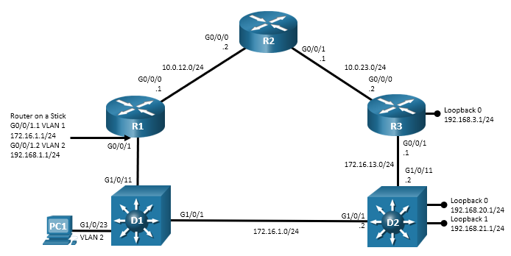

Addressing Table Update:

| Device | Interface | IP Address | Subnet Mask |
| --- | --- | --- | --- |
| R1 | G0/0/0 | 10.0.12.1 | 255.255.255.0 |
| R1 | G0/0/1.1 | 172.16.1.1 | 255.255.255.0 |
| R1 | G0/0/1.2 | 192.168.1.1 | 255.255.255.0 |
| R2 | G0/0/0 | 10.0.12.2 | 255.255.255.0 |
| R2 | G0/0/1 | 10.0.23.1 | 255.255.255.0 |
| R3 | G0/0/0 | 10.0.23.2 | 255.255.255.0 |
| R3 | G0/0/1 | 172.16.1.2 | 255.255.255.0 |
| R3 | Loopback 0 | 192.168.3.1 | 255.255.255.0 |
| D2 | G1/0/1 | 172.16.1.2 | 255.255.255.0 |
| D2 | G1/0/11 | 172.16.13.2 | 255.255.255.0 |
| D2 | Loopback 0 | 192.168.20.1 | 255.255.255.0 |
| D2 | Loopback 1 | 192.168.21.1 | 255.255.255.0 |
| PC1 | NIC | DHCP | |

Scenario:

Switch D2 was converted to support Inter-VLAN routing and is connected to the network via two routed ports. Switch D2 was also configured to join the EIGRP domain, but it is not forming adjacencies.

Use the commands listed below to load the configuration files for this trouble ticket:

|  |  |
| --- | --- |
| Device | Command |
| R1 | **copy flash:/enarsi/4.1.2.3-r1-config.txt run** |
| R2 | **copy flash:/enarsi/4.1.2.3-r2-config.txt run** |
| R3 | **copy flash:/enarsi/4.1.2.3-r3-config.txt run** |
| D1 | **copy flash:/enarsi/4.1.2.3-d1-config.txt run** |
| D2 | **copy flash:/enarsi/4.1.2.3-d2-config.txt run** |

* PC1 should be configured for and receive an address from an IPv4 DHCP server.
* Passwords on all devices are **cisco12345**. If a username is required, use **admin**.
* After you have fixed the ticket, change the MOTD on EACH DEVICE using the following command:

**banner motd # This is $(hostname) FIXED from ticket <ticket number> #**

* Then save the configuration by issuing the **wri** command (on each device).
* Inform your instructor that you are ready for the next ticket.
* After the instructor approves your solution for this ticket, issue the **reset.now** privileged EXEC command. This script will clear your configurations and reload the devices.

# Router Interface Summary Table

| Router Model | Ethernet Interface #1 | Ethernet Interface #2 | Serial Interface #1 | Serial Interface #2 |
| --- | --- | --- | --- | --- |
| 1800 | Fast Ethernet 0/0 (F0/0) | Fast Ethernet 0/1 (F0/1) | Serial 0/0/0 (S0/0/0) | Serial 0/0/1 (S0/0/1) |
| 1900 | Gigabit Ethernet 0/0 (G0/0) | Gigabit Ethernet 0/1 (G0/1) | Serial 0/0/0 (S0/0/0) | Serial 0/0/1 (S0/0/1) |
| 2801 | Fast Ethernet 0/0 (F0/0) | Fast Ethernet 0/1 (F0/1) | Serial 0/1/0 (S0/1/0) | Serial 0/1/1 (S0/1/1) |
| 2811 | Fast Ethernet 0/0 (F0/0) | Fast Ethernet 0/1 (F0/1) | Serial 0/0/0 (S0/0/0) | Serial 0/0/1 (S0/0/1) |
| 2900 | Gigabit Ethernet 0/0 (G0/0) | Gigabit Ethernet 0/1 (G0/1) | Serial 0/0/0 (S0/0/0) | Serial 0/0/1 (S0/0/1) |
| 4221 | Gigabit Ethernet 0/0/0 (G0/0/0) | Gigabit Ethernet 0/0/1 (G0/0/1) | Serial 0/1/0 (S0/1/0) | Serial 0/1/1 (S0/1/1) |
| 4300 | Gigabit Ethernet 0/0/0 (G0/0/0) | Gigabit Ethernet 0/0/1 (G0/0/1) | Serial 0/1/0 (S0/1/0) | Serial 0/1/1 (S0/1/1) |

**Note**: To find out how the router is configured, look at the interfaces to identify the type of router and how many interfaces the router has. There is no way to effectively list all the combinations of configurations for each router class. This table includes identifiers for the possible combinations of Ethernet and Serial interfaces in the device. The table does not include any other type of interface, even though a specific router may contain one. An example of this might be an ISDN BRI interface. The string in parenthesis is the legal abbreviation that can be used in Cisco IOS commands to represent the interface.

End of document